PHP Exercise 7

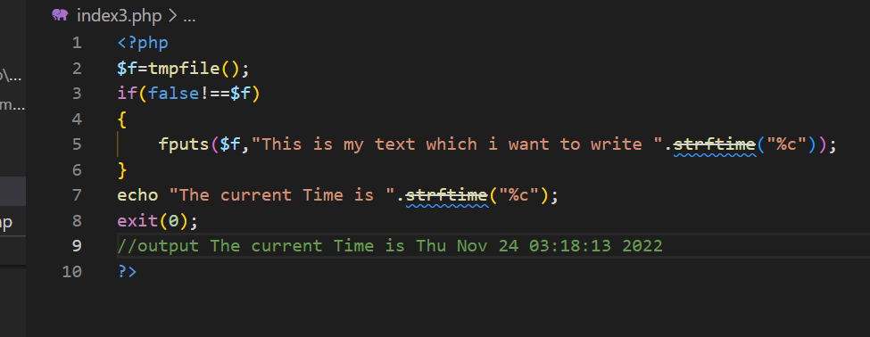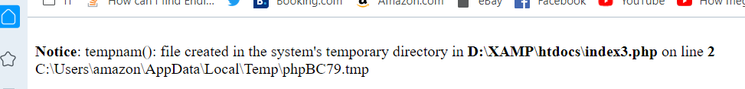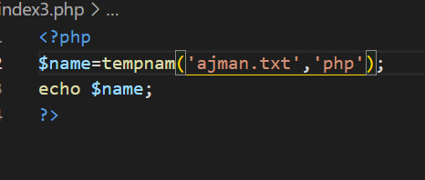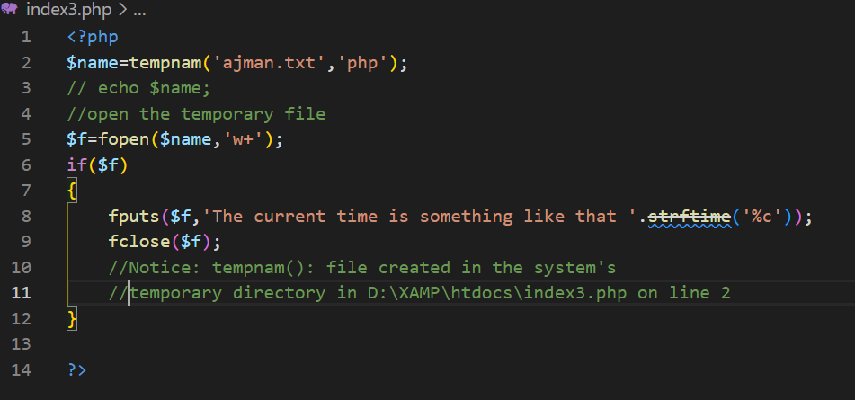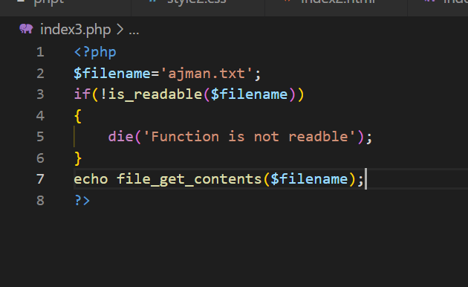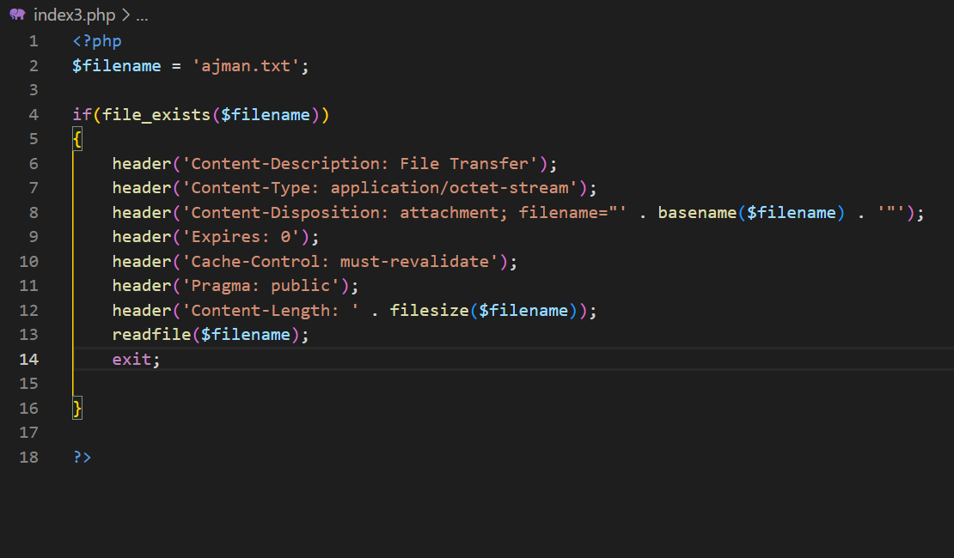

//download file with downloading rate

<?php

$file_to_download = 'ajman.txt';

$client_file = 'mybook.txt';

$download_rate = 200; // 200Kb/s

$f = null;

try {

    if (!file_exists($file_to_download)) {

        throw new Exception('File ' . $file_to_download . ' does not exist');

    }

    if (!is_file($file_to_download)) {

        throw new Exception('File ' . $file_to_download . ' is not valid');

    }

    header('Cache-control: private');

    header('Content-Type: application/octet-stream');

    header('Content-Length: ' . filesize($file_to_download));

    header('Content-Disposition: filename=' . $client_file);

    // flush the content to the web browser

    flush();

    $f = fopen($file_to_download, 'r');

    while (!feof($f)) {

        // send the file part to the web browser

        print fread($f, round($download_rate * 1024));

        // flush the content to the web browser

        flush();

        // sleep one second

        sleep(1);

    }

} catch (\Throwable $e) {

    echo $e->getMessage();

} finally {

    if ($f) {

        fclose($f);

    }

}

?>

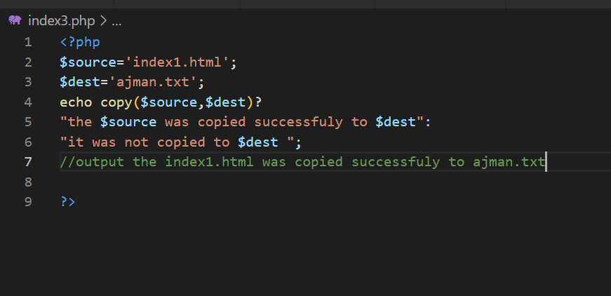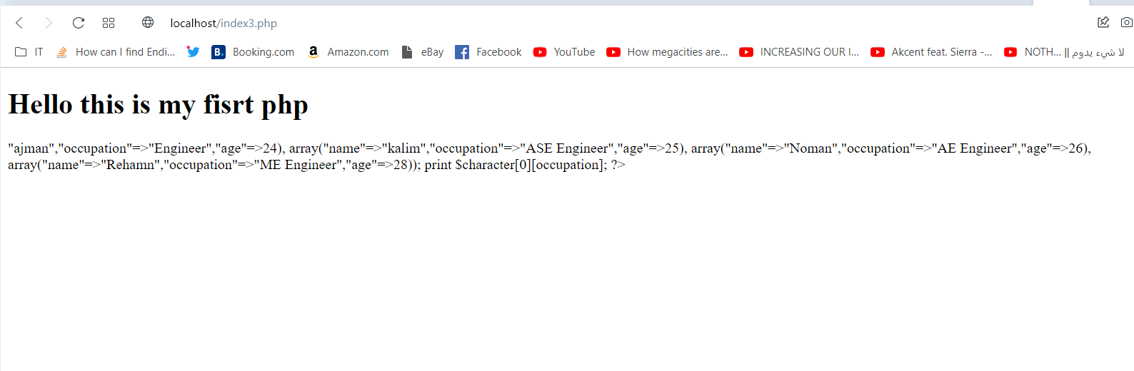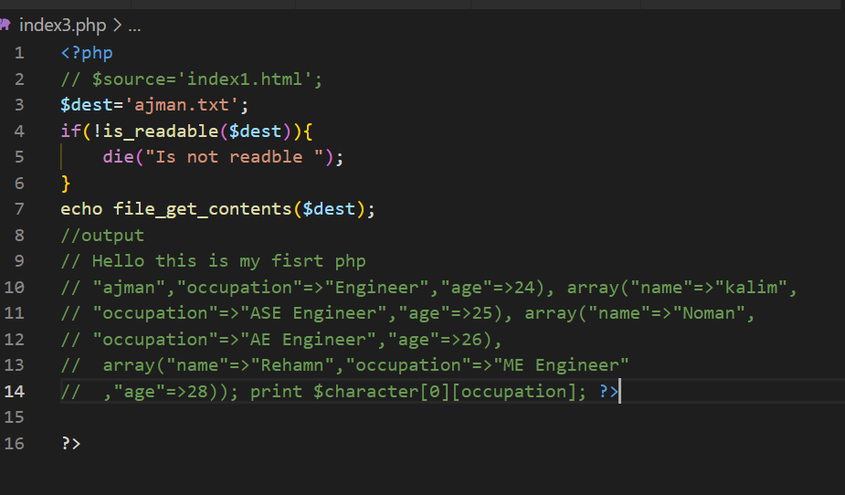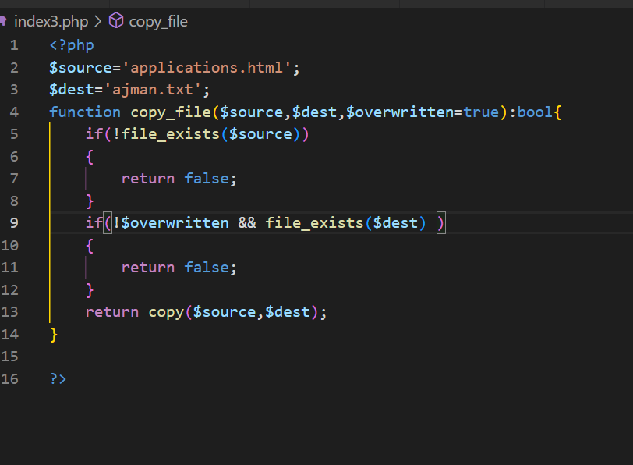

<?php

$source='applications.html';

$dest='ajman.txt';

function copy_file($source,$dest,$overwritten=true):bool{

    if(!file_exists($source))

    {

        return false;

    }

    if(!$overwritten && file_exists($dest) )

    {

        return false;

    }

    return copy($source,$dest);

}

?>

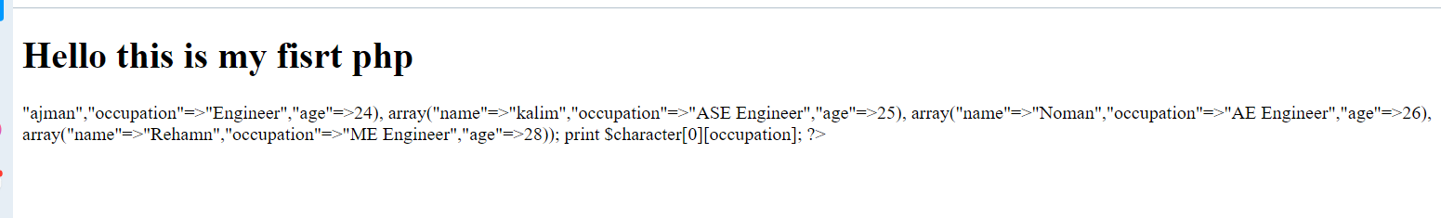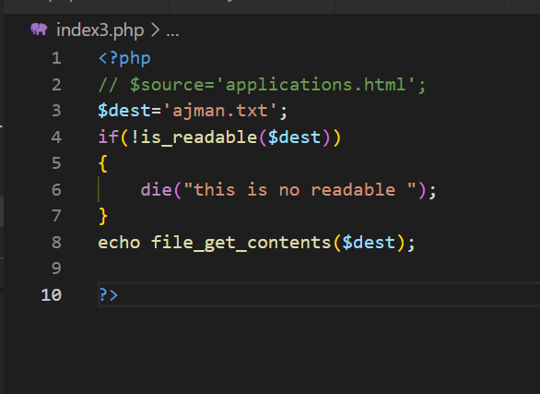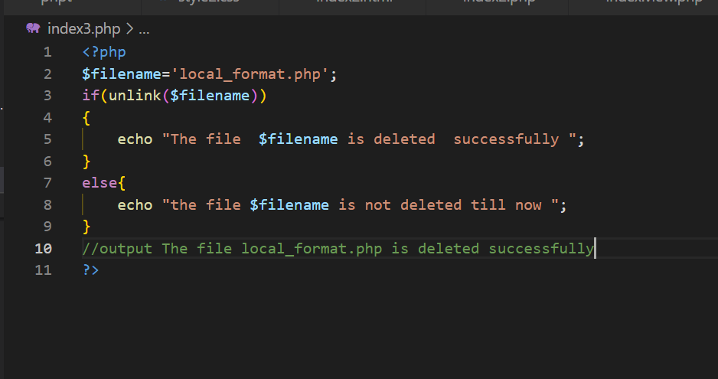

<?php

$filename='local_format.php';

if(unlink($filename))

{

    echo "The file  $filename is deleted  successfully ";

}

else{

    echo "the file $filename is not deleted till now ";

}

//output The file local_format.php is deleted successfully

?>

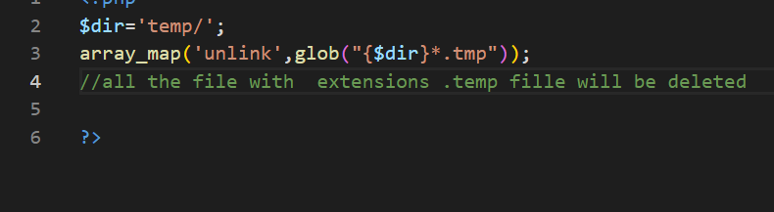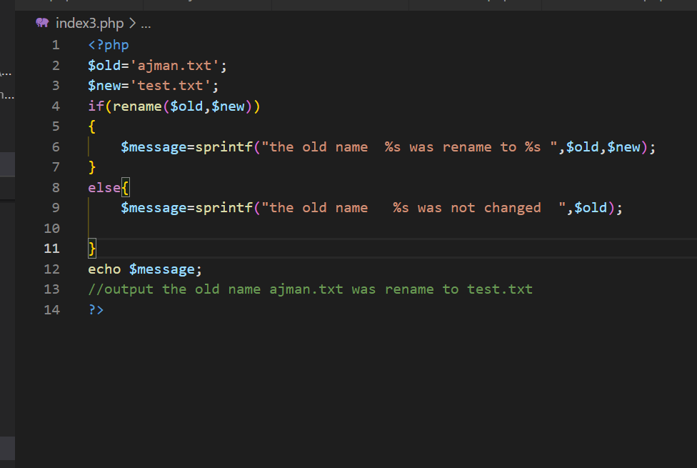

<?php

$old='ajman.txt';

$new='test.txt';

if(rename($old,$new))

{

    $message=sprintf("the old name  %s was rename to %s ",$old,$new);

}

else{

    $message=sprintf("the old name   %s was not changed  ",$old);

}

echo $message;

//output the old name ajman.txt was rename to test.txt

?>

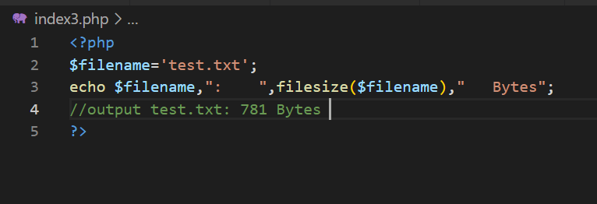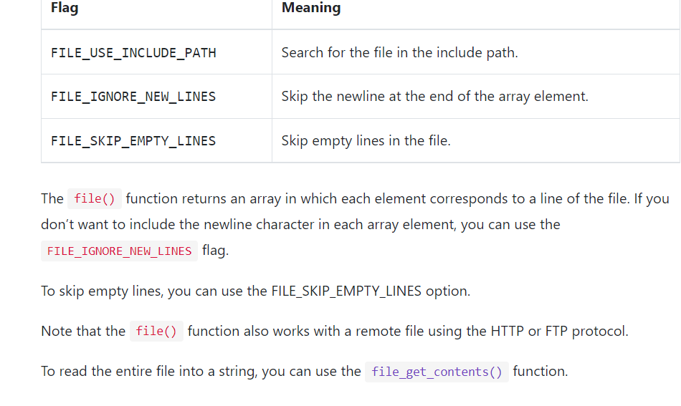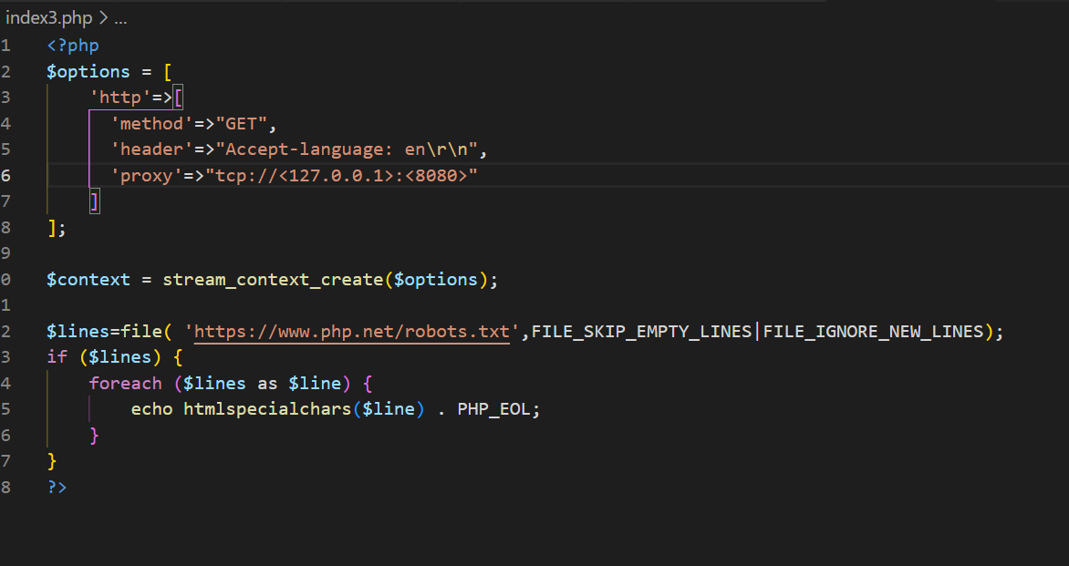

<?php

$options = [

    'http'=>[

      'method'=>"GET",

      'header'=>"Accept-language: en\r\n",

      'proxy'=>"tcp://<127.0.0.1>:<8080>"

    ]

];

$context = stream_context_create($options);

$lines=file( 'https://www.php.net/robots.txt',FILE_SKIP_EMPTY_LINES|FILE_IGNORE_NEW_LINES);

if ($lines) {

    foreach ($lines as $line) {

        echo htmlspecialchars($line) . PHP_EOL;

    }

}

?>

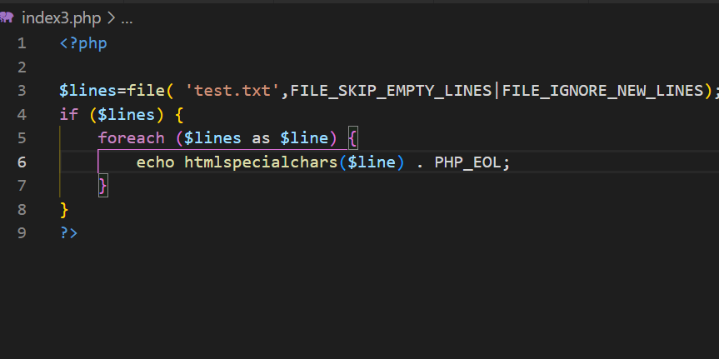

Output:

<!DOCTYPE html> <html lang="en"> <head> <meta charset="UTF-8"> <meta http-equiv="X-UA-Compatible" content="IE=edge"> <meta name="viewport" content="width=device-width, initial-scale=1.0"> <title>Document</title> </head> <body> <div> <h1 style="text-align-last: aria-atomic;text-decoration: dotted;size: 50px;">Hello this is my fisrt php</h1> <?php $character=array(array("name"=>"ajman","occupation"=>"Engineer","age"=>24), array("name"=>"kalim","occupation"=>"ASE Engineer","age"=>25), array("name"=>"Noman","occupation"=>"AE Engineer","age"=>26), array("name"=>"Rehamn","occupation"=>"ME Engineer","age"=>28)); print $character[0][occupation]; ?> </div> </body> </html>

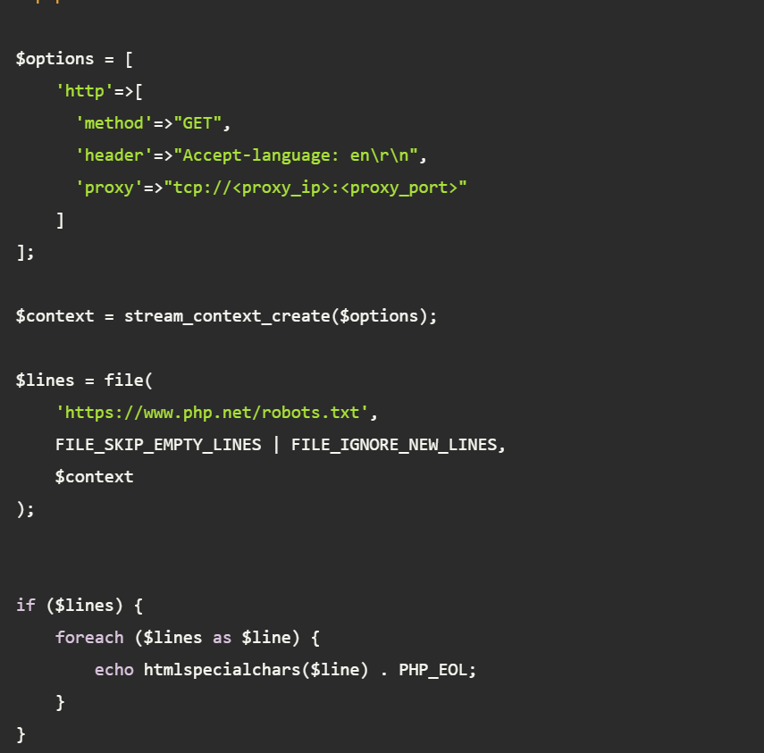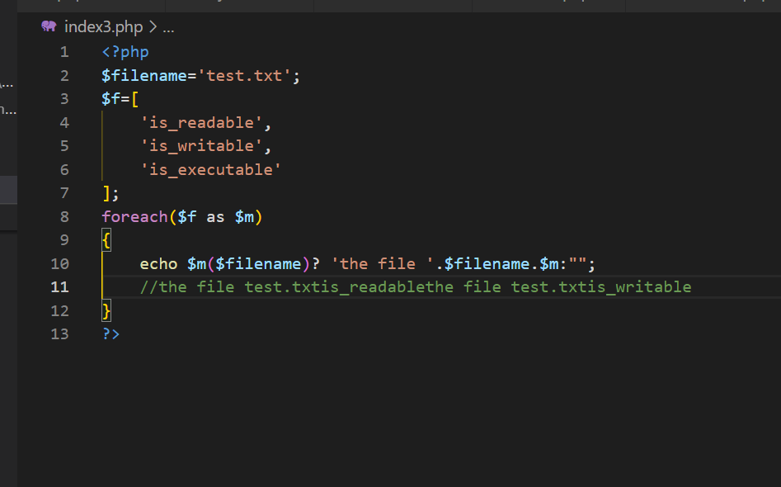

<?php

$filename='test.txt';

$f=[

    'is_readable',

    'is_writable',

    'is_executable'

];

foreach($f as $m)

{

    echo $m($filename)? 'the file '.$filename.$m:"";

    //the file test.txtis_readablethe file test.txtis_writable

}

?>

## Changing file permissions

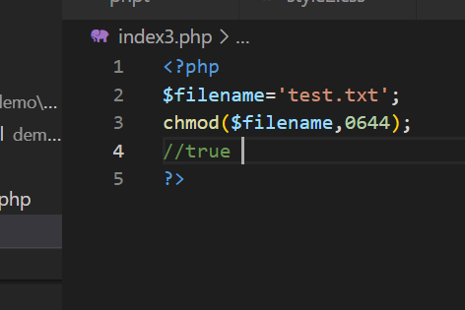

<?php

$data = [

    ['Symbol', 'Company', 'Price'],

    ['GOOG', 'Google Inc.', '800'],

    ['AAPL', 'Apple Inc.', '500'],

    ['AMZN', 'Amazon.com Inc.', '250'],

    ['YHOO', 'Yahoo! Inc.', '250'],

    ['FB', 'Facebook, Inc.', '30'],

];

$filename = 'data.csv';

// open csv file for writing

$f = fopen($filename, 'w');

if ($f === false)

{

    die('Error opening the file ' . $filename);

}

// write each row at a time to a file

foreach ($data as $row)

{

    fputcsv($f,$row);

}

// close the file

fclose($f);

?>

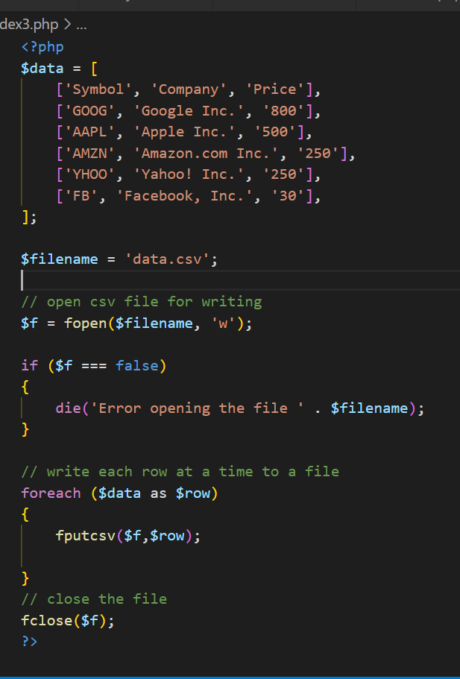

**How to read entire file in php**

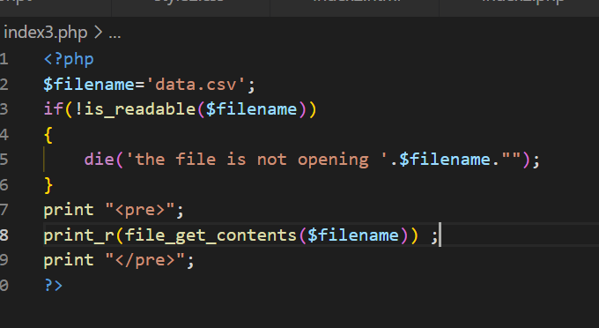

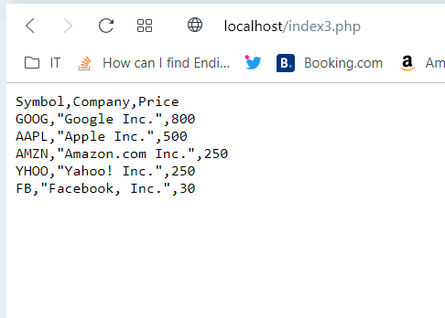

<?php

$filename='data.csv';

if(!is_readable($filename))

{

    die('the file is not opening '.$filename."");

}

print "<pre>";

print_r(file_get_contents($filename)) ;

print "</pre>";

?>

// How to write a file and edit it

**How to write a file and puts values of another file**

$stock=[['symbol12','company11','peice13'],

['symbol2','company2','peice'],['symbol7','company7','peice7'],

['symbol3','company3','peice'],

['symbol4','company4','peice'],

['symbol5','company5','peice'],

['symbol6','company6','peice']];

$f=fopen('data.csv','w');

if($f===false)

{

    die("the file is not opening ".$f."");

}

foreach($stock as $stk)

{

    fputcsv($f,$stk);

}

fclose($f);

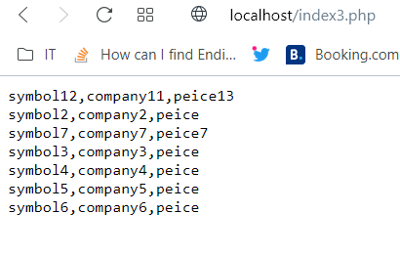

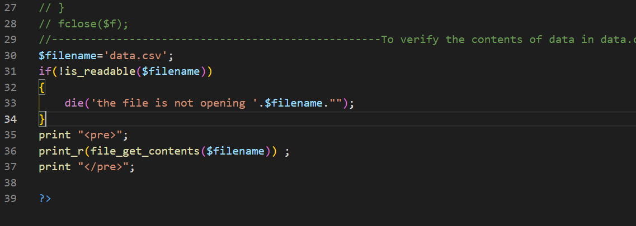

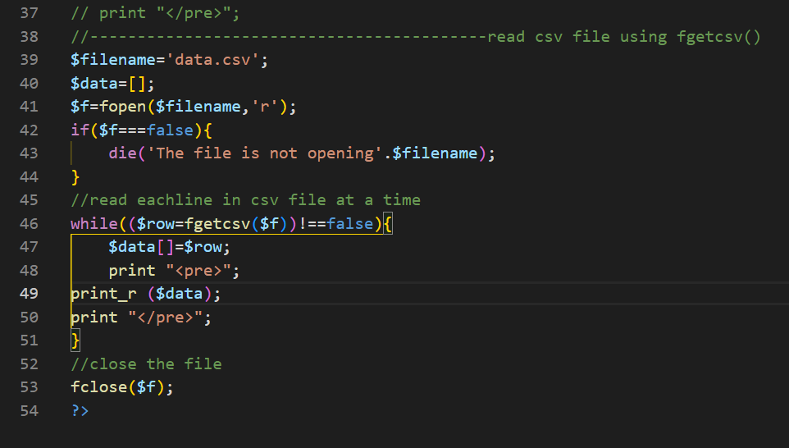

Output:

Array

(

[0] => Array

(

[0] => symbol12

[1] => company11

[2] => peice13

)

)

Array

(

[0] => Array

(

[0] => symbol12

[1] => company11

[2] => peice13

)

[1] => Array

(

[0] => symbol2

[1] => company2

[2] => peice

)

)

Array

(

[0] => Array

(

[0] => symbol12

[1] => company11

[2] => peice13

)

[1] => Array

(

[0] => symbol2

[1] => company2

[2] => peice

)

[2] => Array

(

[0] => symbol7

[1] => company7

[2] => peice7

)

)

Array

(

[0] => Array

(

[0] => symbol12

[1] => company11

[2] => peice13

)

[1] => Array

(

[0] => symbol2

[1] => company2

[2] => peice

)

[2] => Array

(

[0] => symbol7

[1] => company7

[2] => peice7

)

[3] => Array

(

[0] => symbol3

[1] => company3

[2] => peice

)

)

Array

(

[0] => Array

(

[0] => symbol12

[1] => company11

[2] => peice13

)

[1] => Array

(

[0] => symbol2

[1] => company2

[2] => peice

)

[2] => Array

(

[0] => symbol7

[1] => company7

[2] => peice7

)

[3] => Array

(

[0] => symbol3

[1] => company3

[2] => peice

)

[4] => Array

(

[0] => symbol4

[1] => company4

[2] => peice

)

)

Array

(

[0] => Array

(

[0] => symbol12

[1] => company11

[2] => peice13

)

[1] => Array

(

[0] => symbol2

[1] => company2

[2] => peice

)

[2] => Array

(

[0] => symbol7

[1] => company7

[2] => peice7

)

[3] => Array

(

[0] => symbol3

[1] => company3

[2] => peice

)

[4] => Array

(

[0] => symbol4

[1] => company4

[2] => peice

)

[5] => Array

(

[0] => symbol5

[1] => company5

[2] => peice

)

)

Array

(

[0] => Array

(

[0] => symbol12

[1] => company11

[2] => peice13

)

[1] => Array

(

[0] => symbol2

[1] => company2

[2] => peice

)

[2] => Array

(

[0] => symbol7

[1] => company7

[2] => peice7

)

[3] => Array

(

[0] => symbol3

[1] => company3

[2] => peice

)

[4] => Array

(

[0] => symbol4

[1] => company4

[2] => peice

)

[5] => Array

(

[0] => symbol5

[1] => company5

[2] => peice

)

[6] => Array

(

[0] => symbol6

[1] => company6

[2] => peice

)

)

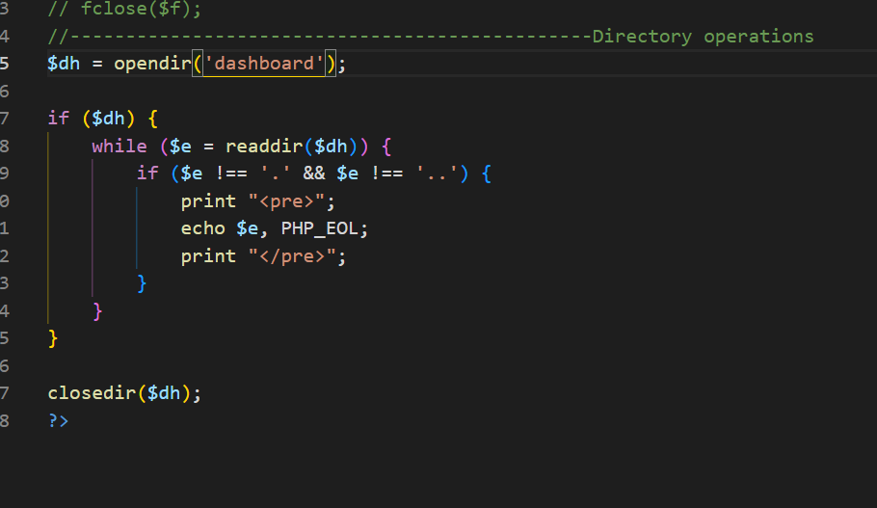

$dh = opendir('dashboard');

if ($dh) {

    while ($e = readdir($dh)) {

        if ($e !== '.' && $e !== '..') {

            print "<pre>";

            echo $e, PHP_EOL;

            print "</pre>";

        }

    }

}

closedir($dh);

